H.T No
Regulations:
A18

Sreenidhi Institute of Science and Technology
(An Autonomous Institution)
Code No: 7HC12 Date: 08-Oct-2020 (FN)

B.Tech II-Year I-Semester External Examination, October - 2020 (Supplementary)
ENGINEERING MATHEMATICS-III (CIVIL and me)

Time: 2 Hours Max.Marks:70

Note: a) No additional answer sheets will be provided.
b) All sub-parts of a question must be answered at one place only, otherwise it will not be valued.
c) Missing data can be assumed suitably.

ANSWER ANY FIVE QUESTIONS. EACH QUESTION CARRIES 14 MARKS.

1. | a) | Find the general solution of the differential equation  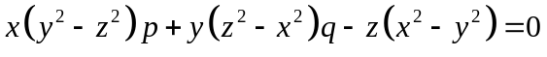. | [7M]
 | b) | Using the transformations 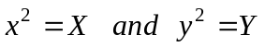, reduce the partial differential equation 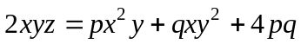 to Clairaut’s form and hence solve it. | [7M]
2. |  | A homogeneous rod of conducting material of length 100 cm has its ends kept at zero temperature and the temperature initially is 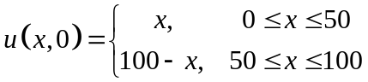. Find the temperature 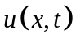 at any time. | [14M]
3. | a) | A bag A contains 2 white and 3 red balls and a bag B contains 4 white and 5 red balls. One ball is drawn at random from one of the bags and it is found to be red. Find the probability that the red ball is drawn from bag B. | [7M]
 | b) | A discrete random variable X has the mean 6 and variance 2.It is assumed that the distribution is binomial. Find 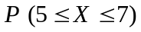. | [7M]
4. |  | A population consists of five numbers 6,8,10,12,14. If all samples of  size 2 are drawn from this population with replacement . Find  i) the total number of samples with replacement  ii) the mean of the population  iii) the standard deviation of the population  iv) the mean of the sampling distribution of means and  v) the standard deviation of the sampling distribution of means. . | [14M]
5. | a) | Explain types of errors in sampling. | [7M]
 | b) | A sample of 64 students have a mean weight of 70 kgs. Can this  be regarded as a sample from a population with mean weight 56 kgs and standard deviation 25 kgs ? | [7M]
6. |  | Test for goodness of fit of poisson distribution at 5% level  of significance to the following distribution. | [14M]
7. | a) | Form a partial differential equation by eliminating arbitrary function ‘f’ from 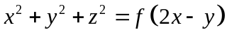. | [7M]
 | b) | A continuous random variable X has the p.d.f.  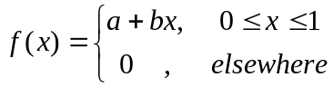 . If the mean of the distribution is ,  find the values of and . | [7M]
8. | a) | Explain briefly interval estimation. | [7M]
 | b) | Find the students t (test statistic) for the variable values - 4,- 2,- 2,0,2,2,3,3 in sample of 8, taking the mean of the universe to be zero. | [7M]

-- 00 -- 00 –

